Is Australia heading towards recession?

Hypothesis: something has got to give, whether its housing prices, car loans,

Also, because so many housing loans are locked into previously historically low interest rates, many households are reluctant to sell their properties in the current housing market. The extremely high-interest rates are also discouraging newcomers into the market.

Treasury Yields (government bonds and returns etc.) at risk-free rates. Usually, when bond yields are high, it means people are pulling out of risky investments (pulling money from banks).

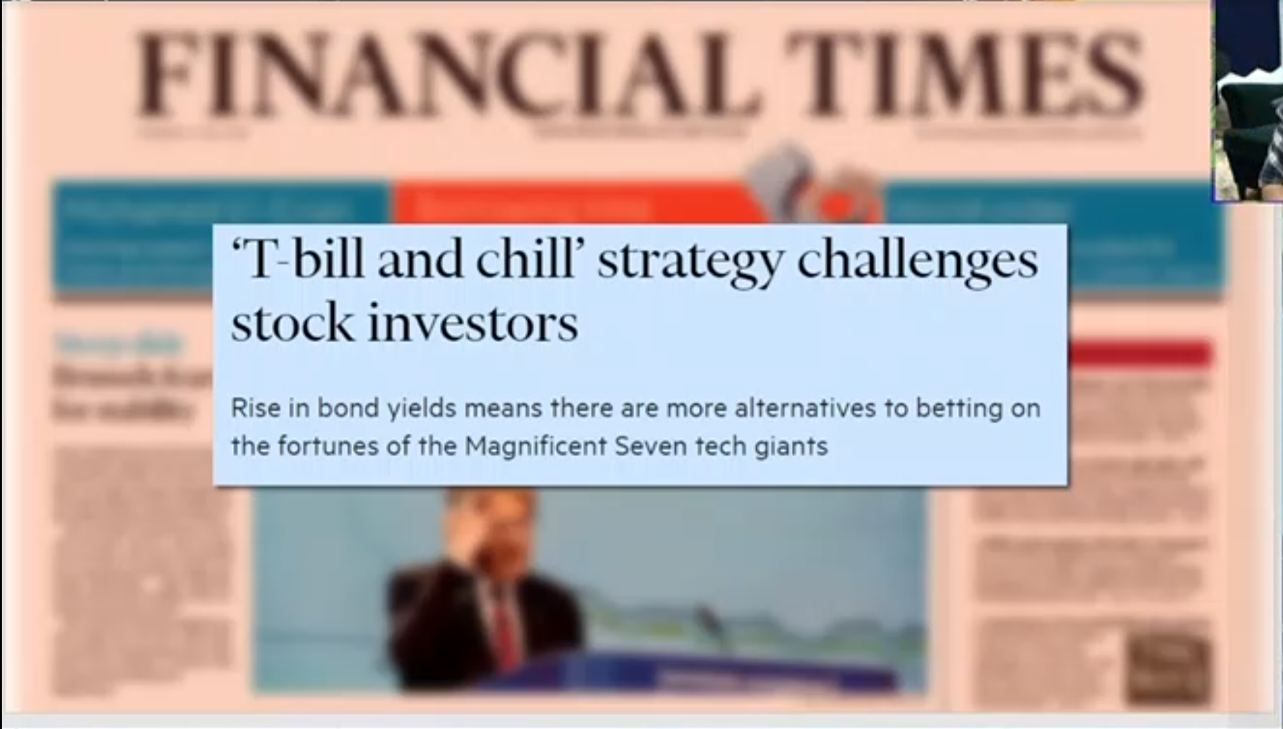

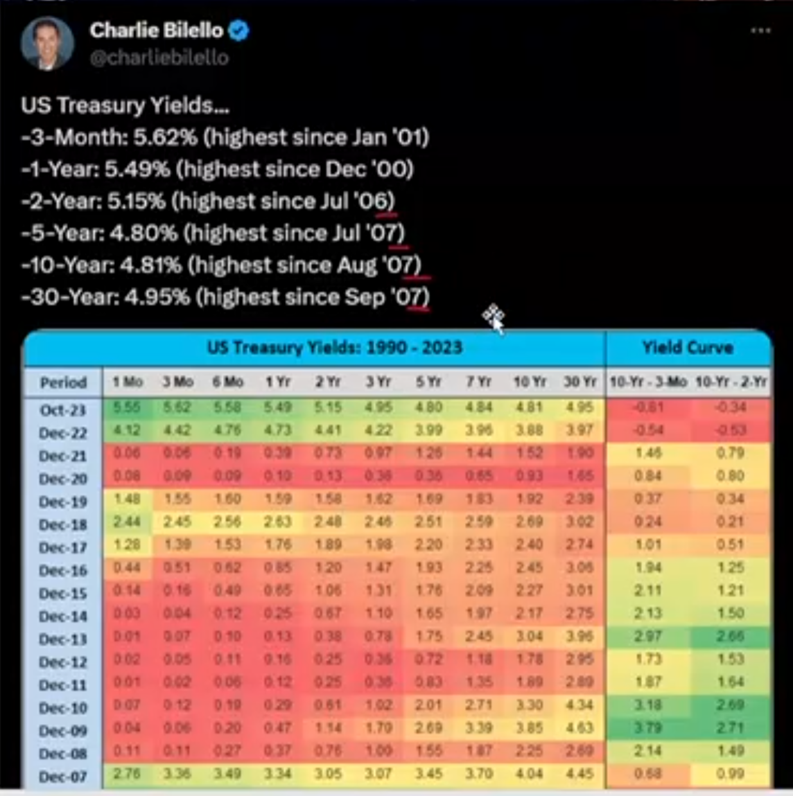

What happened in 2008 was, housing bubbles lead to banks loaning out bad loans, then banks sold these bad loans as mortgage-backed securities (MBS) to investors, which spread the financial risks throughout the economies. Then once the big banks filed bankruptcy, Banks couldn’t lend out money anymore to each other because their uncertainty about the value of the assests. businesses, and thus

Lead with Interest rate changes, to

Average Annual Real estate prices/yr compared against Median Household Income

To calculate how many years it takes for the average household to afford houses.

Bonds on average has been the highest it’s been since the end of the 2008 financial crisis